UNIVERSITY OF RWANDA



COLLEGE OF SCIENCE AND TECHNOLOGY

SCHOOL OF ICT

DEPARTMENT OF COMPUTER AND SOFTWARE ENGINEERING

YEAR 3

Module title: Computational Intelligence and Application

Project name: IKIBONDO

Group members:
TUMUKUNDE Gentille 223021200

IRUMVA Gad Anaclet 223000471

On December 14th, 2025
Table of Contents
Abstract 3
1. Introduction 3
1.1 Literature Review 4
1.2 Objective of the study 5
2 Study Area and Data Preparation 5
2.1 Study Area 6
2.2 Data Description and Preprocessing 6
2.3 Feature and Correlation Analysis 11
3 Methodology 12
3.1 Model Preparation 12
3.2 Pipelines Creation and Model Training 13
3.3 Problem Formulation 13
3.4 Model Evaluation 16
3.5 Vaccination Scheduling Logic 17
4 Results and Discussion 18
4.1 Model performance comparison 18
4.2 Feature importance analysis (Decision Tree) 20
4.3 Confusion matrix and error analysis 21
4.4 Discussion of results (why Decision Tree fits IKIBONDO) 23
4.5 Error patterns and clinical meaning 23
4.6 Discussion of Results 23
5 Conclusion 24
DECLARATION 25
ACKNOWLEDGEMENTS 25
Appendices 26

Table of Figures:
Figure 1 Paper-based gap vs IKIBONDO workflow 5
Figure 2 Ikibondo integration 6
Figure 3 Data Preprocessing 7
Figure 4 Class Distribution in Training Data 11
Figure 5 Class Distribution: Impact of SMOTE 13
Figure 6 All model performance analysis 17
Figure 7 Rule-based Vaccination adherence and alerting in IKIBONDO 18
Figure 8 Ikibondo System Pipeline: Data to Deployment 19
Figure 9 Machine Learning Models 19
Figure 10 Decision Tree Detailed performance metrics 20
Figure 11 Feature Important analysis 21
Figure 12 Confusion matrix 21
Figure 13 Actual vs predicted class distribution (Decision Tree) 22
Figure 14 Prediction Error Plots 24

COMPUTING INTELLIGENCE & APPLICATION COURSES – TRIMESTER 1 September 2025 – January 2026
A Comparative Study of Machine learning models for baby health risk monitoring and vaccination scheduling system (IKIBONDO)
IRUMVA Gad Anaclet (223000471) -TUMUKUNDE Gentille (223021200) (Group members)
University of Rwanda, School of Science and Technology
GitHub link, remember to save the REQUIREMENT FILES of Package Versions as well

Abstract
IKIBONDO is an integrated, AI-driven child health monitoring and vaccination scheduling system designed to support early detection of clinical risk among children aged 0-6 years in Rwanda. Despite significant progress in community-based healthcare delivery, many health facilities and Community Health Workers (CHWs) still rely on paper-based growth charts and vaccination cards, which are prone to loss, inconsistencies, and delayed clinical action. These challenges contribute to missed vaccinations, delayed identification of health risks, and preventable child morbidity. This project presents the design, implementation, and evaluation of a machine learning based health risk prediction model combined with a rule-based vaccination adherence system. Using a synthetic dataset of 100,000 newborn and infant health records, extensive preprocessing and feature engineering were applied to derive 39 clinically meaningful features, including anthropometric indicators, vital signs, demographic variables, and vaccination status. Five machine learning models Logistic Regression, k-Nearest Neighbors, Decision Tree, Random Forest, and Gradient Boosting were trained and evaluated under severe class imbalance conditions. To address imbalance between Low, Medium, and High-risk classes, the Synthetic Minority Oversampling Technique (SMOTE) was applied to the training dataset. Model performance was assessed using accuracy and Macro F1-score, with particular emphasis on Macro F1 to ensure balanced sensitivity across all risk categories. Experimental results show that the Decision Tree classifier achieved the highest Macro F1-score (0.329), offering the best trade-off between predictive performance and interpretability for clinical screening applications. In parallel, vaccination adherence was modeled using deterministic rules derived from Rwanda's national immunization schedule. This module classifies vaccination status into Good, Medium, or Poor and generates actionable alerts for overdue or upcoming vaccines. The integration of machine learning and rule-based logic within IKIBONDO provides a practical decision-support tool for CHWs and clinicians, improving early intervention, vaccination coverage, and child health outcomes in resource-limited settings.
Keywords: Machine Learning, Child Health Monitoring, Vaccination Scheduling, Rwanda, Decision Tree, SMOTE, WHO Growth Standards, Clinical Decision Support

1. Introduction
Child survival and healthy development depend strongly on timely identification of growth faltering, acute illness warning signs, and missed preventive services such as immunization. In Rwanda, Community Health Workers (CHWs) have played a central role for decades in delivering primary health services and supporting under-five care at community level. However, immunization and child monitoring workflows still commonly start with paper artifacts (for example, the child’s immunization card and facility paper registers), which can increase duplication of work and introduce delays when data must be re-entered into electronic systems.​
Routine child monitoring typically relies on anthropometric indicators (e.g., weight-for-age and length/height-for-age) interpreted against global growth standards, which provide a consistent reference for assessing child growth under optimal conditions. When data capture is incomplete or difficult to interpret, longitudinal tracking becomes harder, and opportunities for earlier intervention can be missed; evidence from Rwanda has shown that paper-based child growth records can be fragmented and hard to read compared with electronic data collection approaches. At the same time, immunization schedules are increasingly complex, and reminder/recall interventions have been shown to raise vaccination uptake on average across studies, indicating that systematic follow-up mechanisms can improve coverage.​
Motivated by these realities, IKIBONDO is designed as an integrated decision-support approach that combines machine learning based child health risk classification with structured vaccination adherence evaluation aligned to schedule rules, so that a CHW or clinician can receive a clear risk signal and a practical immunization follow-up status from the same child record. The goal is not to replace clinical judgment, but to strengthen screening and prioritization by using standardized growth concepts alongside algorithmic pattern detection, while keeping outputs interpretable for real-world use in resource-limited settings.

1.1 Literature Review
Digital health information systems have become increasingly important in child health programs because they improve continuity of records, reduce transcription errors, and enable faster follow-up compared with paper-only workflows. In Rwanda’s primary healthcare context, CHWs play a long-established role in delivering community-based services and linking households to facilities, which makes them a natural target group for decision-support tools that must work at the point of care. However, many health programs still operate with mixed documentation practices (paper plus electronic tools), and this dual approach can produce inconsistencies and additional workload, especially when the same information must be captured twice or reconciled later.​
A major component of child health monitoring is growth assessment, typically based on anthropometric indicators such as weight-for-age and length/height-for-age interpreted against WHO child growth standards. These standards provide a widely accepted reference for evaluating whether a child’s growth trajectory is within expected ranges under healthy conditions, which is why they are frequently used in clinical screening and public health monitoring. Evidence from Rwanda has shown that electronic approaches to growth record capture can improve data quality, including better consistency checks and reduced error compared with paper recording, which supports the argument that digitized workflows can strengthen monitoring when designed to match user practice.​ For immunization programs, monitoring and defaulter tracking depend on reliable individual-level vaccination histories and timely identification of missed doses.
Rwanda has implemented an electronic immunization registry (e-Tracker) with the intent to improve data quality and enable monitoring of defaulters or dropouts, but research-based evaluations indicate that workflow fit, response times, training, and user support can strongly affect effective use in routine practice. Broader evidence across settings also suggests that fully electronic or fully paper environments may show better data accuracy than “dual paper-electronic” implementation, reinforcing the need for careful integration planning when introducing digital tools.​ From a predictive analytics perspective, many child-risk classification problems face severe class imbalance because truly high-risk cases are relatively rare compared to low-risk observations.
Studies on imbalanced learning highlight that oversampling approaches such as SMOTE and related methods can improve minority-class learning by generating synthetic samples, but they must be applied carefully to avoid distortion and leakage (for example, applying SMOTE only on training data). This motivates evaluation approaches that prioritize balanced performance across classes (such as Macro F1-score), rather than relying on accuracy alone, because a model can appear “good” while still failing to detect minority high-risk cases.​​
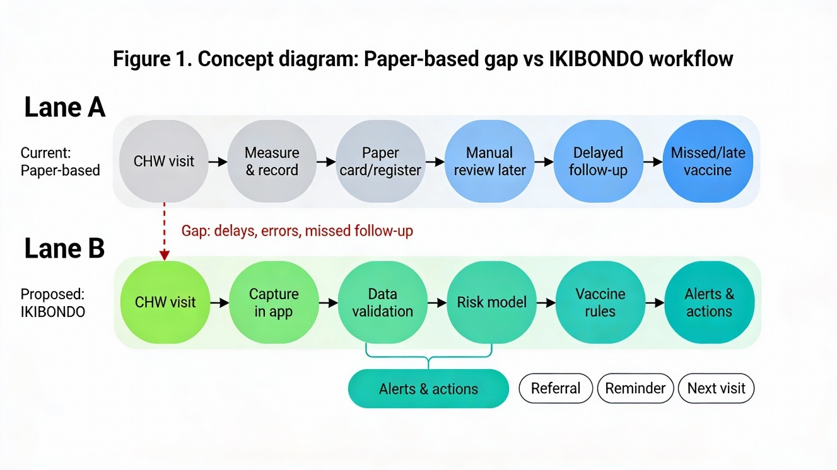
Figure 1 Paper-based gap vs IKIBONDO workflow

1.2 Objective of the study
The primary objective of IKIBONDO is to design and evaluate an integrated child health decision-support approach that combines machine learning based health risk prediction with rule-based vaccination adherence assessment in a single workflow. The goal is to provide outputs that are usable during community and facility encounters: a clear health risk category (Low/Medium/High) and an immunization adherence status that can trigger practical follow-up actions. Because real-world screening data tends to be imbalanced, a key objective is also to implement a training strategy that addresses minority-class underrepresentation (using SMOTE in the training set) and to evaluate models using metrics that reflect balanced class performance (especially Macro F1-score).​​
A further objective is to strengthen interpretability and trust by emphasizing models and analyses that can be explained to health workers, including feature-level explanations (e.g., feature importance or transparent decision rules) and diagnostic evaluation visuals (e.g., confusion matrices). In this way, IKIBONDO is positioned not as a replacement for clinical judgment, but as a structured aid that improves prioritization, early flagging of risk patterns, and systematic immunization follow-up.​​

2 Study Area and Data Preparation
The study is situated within Rwanda’s community and primary healthcare delivery environment, where CHWs form a bridge between households and health facilities by supporting routine child monitoring, referrals, and preventive service follow-up. This context is important because the value of predictive models is not only statistical performance, but also whether the outputs can be incorporated into real workflows that may include time constraints, limited connectivity, and mixed paper electronic processes. Consequently, data preparation is treated as a core part of the method: the dataset must represent plausible clinical ranges, contain variables that reflect real monitoring practice (growth and vaccination history), and be structured so that evaluation is reliable and reproducible.​​

2.1 Study Area
Rwanda’s community health system relies on CHWs as frontline providers for household-level monitoring and linkage to facility services, including maternal and child health activities. In practice, child health monitoring requires repeated measurements over time, so the information system must support longitudinal consistency (tracking the same child’s data across visits) and must reduce common recording errors that affect interpretation. The immunization component is similarly longitudinal: a child’s vaccination status is not a single event, but a sequence of doses that must be administered according to age and timing rules, which increases the risk of missed follow-ups if monitoring is not systematic.​
For this reason, the IKIBONDO context emphasizes the integration of growth monitoring and immunization adherence in one decision-support flow, so that health workers can see a combined view rather than separate tools that fragment attention. This aligns with evidence that adoption and usefulness of immunization registries depend strongly on workflow fit and practical functionality in real service delivery settings.​​

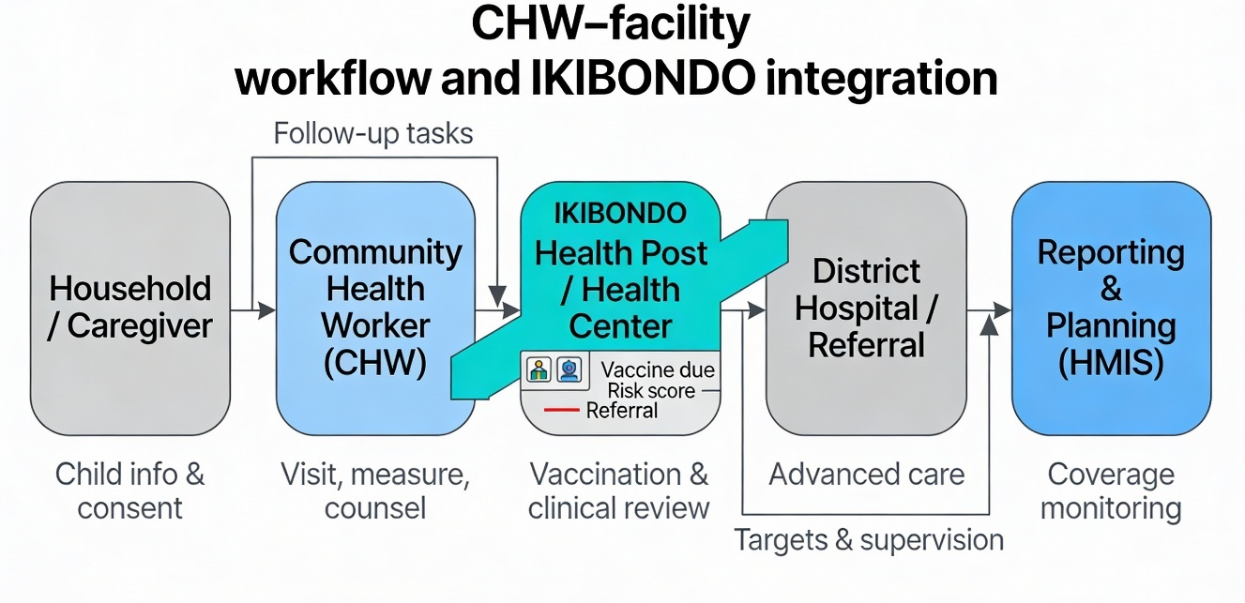
Figure 2 Ikibondo integration

2.2 Data Description and Preprocessing
This chapter describes the dataset used in the IKIBONDO system, including data sources, structure, preprocessing steps, and feature engineering techniques. Proper data preparation is critical to ensure reliable machine learning performance and meaningful clinical interpretation.
2.2.1 Dataset Description
The IKIBONDO project utilizes a synthetic dataset designed to simulate real-world child health records for children aged 0–6 years. The dataset was generated to reflect realistic distributions of demographic, anthropometric, and clinical indicators observed in pediatric populations. Synthetic data was chosen to address privacy concerns and to allow large-scale experimentation without exposing sensitive patient information.
The dataset contains 100,000 records, each representing a unique child health observation. Each record includes demographic attributes, physical measurements, vital signs, and vaccination-related information. The target variable represents the child's health risk category, classified into three classes: Low Risk, Medium Risk, and High Risk.
Key dataset characteristics:
- Total records: 100,000
- Age range: 0 to 72 months
- Features: 39 engineered features
- Target classes: 3 (Low Risk, Medium Risk, High Risk)
- Missing values: < 5% handled through imputation
2.2.2 Data Collection Assumptions
Although the dataset is synthetic, it is constructed based on established pediatric health guidelines and plausible clinical ranges. The following assumptions were applied during data generation:
- Age values are uniformly distributed between 0 and 72 months
- Anthropometric measurements follow WHO growth standards
- Vital signs are generated within age-appropriate physiological ranges
- Vaccination records align with Rwanda's national immunization schedule
- Health risk labels are derived from combinations of anthropometric and clinical indicators
- Class distribution reflects realistic imbalance: ~70% Low Risk, ~25% Medium Risk, ~5% High Risk
These assumptions ensure that the dataset captures realistic variability while maintaining internal consistency and relevance to Rwanda's health context.
2.2.3 Data Cleaning and Validation
Raw child health datasets whether collected from CHW registers, facility records, or generated synthetically to mimic real workflows often include inconsistencies that can reduce the reliability of both the machine learning risk model and the rule-based vaccination module. Because IKIBONDO combines two components (risk prediction and vaccination scheduling), the data must be accurate enough for clinical feature extraction while also being consistent enough to evaluate vaccine due/overdue rules correctly. For this reason, data preparation was conducted as a structured process that ensures the dataset is complete, consistent, and analytically useful before feature engineering and model training.​

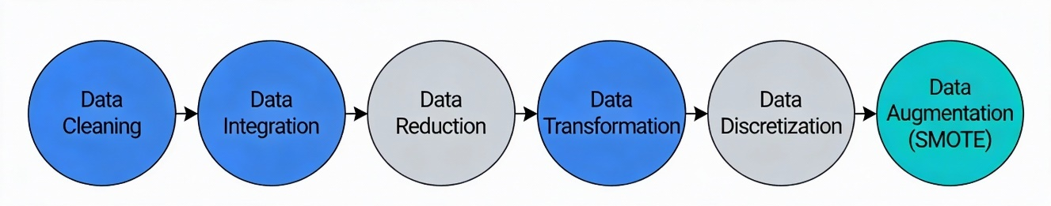
Figure 3 Data Preprocessing
Data Cleaning
Data cleaning focuses on detecting and correcting issues that commonly appear in real-world health records, such as missing values, duplicated rows, and inconsistent entries. In IKIBONDO, cleaning was performed before feature engineering because derived indicators (e.g., BMI, delay-based vaccine features, or age-adjusted growth indicators) can become incorrect if the base variables are incomplete or wrong. The following cleaning operations were applied:​
- Missing Value Handling: Records with missing critical fields (for example age or weight) were handled using two strategies: (i) imputation using a statistical approach (median for numerical variables) when the missingness was limited and reasonable to infer, and (ii) removal when values were too incomplete to recover without introducing strong bias. This strategy ensures that the final dataset preserves enough information for learning while avoiding training on highly uncertain records.​
- Range Validation: Numerical values were checked against clinically plausible ranges so that clearly impossible records (e.g., extreme anthropometric or vital sign values outside expected physiological limits) do not distort the model’s learned decision boundaries. Implausible values were flagged and then either corrected (when the issue appeared to be a unit/format error) or removed when correction was not reliable.​
- Data Type Standardization: All variables were converted into consistent and machine-learning-friendly types (numerical as integers/floats, categorical as category/string before encoding, dates as datetime where used). This step prevents silent pipeline errors (for example, numeric columns read as strings) and ensures that preprocessing operations such as encoding and scaling behave correctly.​
- Duplicate Detection: Duplicate rows were detected and removed to ensure integrity of training and evaluation. Duplicate records can inflate performance metrics by making the test set contain examples already seen during training, and they can bias class distributions by over-representing some children or visit patterns.​
Data Integration
After cleaning, data integration was used to combine information needed for both halves of IKIBONDO into one coherent dataset. This means merging child health attributes (anthropometrics, vital signs, demographic context) with vaccination schedule variables (dose history, dates, expected next vaccine) so that the model can learn risk in the same record where the vaccination module computes adherence. Integration also ensures consistent identifiers and avoids “fragmented records” where health risk is stored separately from immunization history.​
Data Reduction
To improve quality and speed, data reduction was performed by eliminating irrelevant, redundant, or highly correlated fields that do not add meaningful information for prediction. In practice, this helps the models generalize better and reduces training time, especially when multiple candidate algorithms are compared under the same pipeline. Reduction also supports interpretability by limiting the final feature space to variables that are clinically meaningful and easy to explain.​
Data Transformation
Data transformation converts the cleaned dataset into the best format for machine learning and consistent rule evaluation. For IKIBONDO, this includes scaling/normalization of numeric variables when required, encoding of categorical features (e.g., sex/gender), and standardizing unit conventions so that all derived features are computed on comparable scales. Transformation ensures that algorithms that depend on numeric distance or gradient behaviour are not dominated by a few large-scale variables.​
Data Discretization
To support interpretability and some rule-based decisions, continuous variables can be discretized into meaningful bins. In IKIBONDO, age can be discretized into medically meaningful groups (e.g., newborn, infant, toddler, preschool) to simplify reporting and to align analysis with vaccination timing windows. Discretization is also useful for reporting results because it allows summaries such as “overdue vaccines by age group,” which is easy for CHWs and supervisors to interpret.​
Data Augmentation
Finally, data augmentation is used to increase the effective training size and improve learning, especially for minority classes. In IKIBONDO, the main augmentation mechanism is SMOTE, which generates synthetic minority-class samples during training to reduce imbalance between Low, Medium, and High-risk categories. This improves the model’s ability to learn minority-class decision boundaries without simply duplicating rare cases.
2.2.4 Feature Engineering
Feature engineering is a key component of the IKIBONDO system, transforming raw input data into clinically meaningful predictors. A total of 39 features were derived from the original dataset.
2.2.4.1 Anthropometric Features
Anthropometric indicators provide essential information about child growth and nutritional status. Derived features include:
- Weight-for-age ratio (normalized to WHO percentiles)
- Height-for-age ratio (normalized to WHO percentiles)
- Weight-for-height ratio (normalized to WHO percentiles)
- Body Mass Index (BMI) by age group
- Growth velocity indicators
- Age-adjusted z-scores for all anthropometric measures
2.2.4.2 Vital Sign Features
Vital signs such as body temperature, heart rate, and respiratory rate are included to capture acute health conditions. These variables are normalized and age-adjusted to account for physiological differences across age groups:
- Temperature status (normal, elevated, fever)
- Heart rate category (age-adjusted)
- Respiratory rate category (age-adjusted)
- Blood pressure percentile (if available)
2.2.4.3 Demographic and Contextual Features
Demographic attributes include age in months, gender, and geographical indicators. Contextual features such as breastfeeding status and birth weight are also incorporated to enhance predictive accuracy:
- Age in months and age group category
- Gender
- Birth weight status
- Breastfeeding status and duration
- Number of siblings
- Distance to nearest health facility
2.2.4.4 Vaccination-Related Features
Vaccination features capture both adherence and delay information. Derived indicators include:
- Number of vaccines received (total and on-time)
- Number of overdue vaccines
- Longest delay in vaccination administration
- Vaccination coverage percentage
- Days since last vaccine dose
2.2.4.5 Health Outcome Indicators
Composite health indicators synthesize multiple data sources:
- Overall nutritional status score
- Acute health event frequency
- Chronic condition presence
- Healthcare access barriers index
These engineered features capture both individual health indicators and integrated health system performance relevant to clinical risk assessment.
2.2.5 Handling Missing Values and Outliers
Missing values are addressed using a combination of statistical imputation methods:
- Numerical variables: Median imputation (robust to outliers)
- Categorical variables: Mode imputation (most frequent category)
- Time-based variables: Forward-fill or backward-fill where temporal sequence is known
Outliers are identified using statistical thresholds and domain-specific knowledge:
- Extreme values are identified using interquartile range (IQR) method
- Clinical plausibility is assessed for each outlier
- Values are capped within clinically acceptable limits rather than removed
- Records with multiple inconsistencies are excluded from training
2.2.6 Class Distribution and Imbalance Analysis
Analysis of the target variable revealed significant class imbalance, with the majority of records labeled as Low Risk and relatively fewer Medium and High-Risk cases. This imbalance reflects real-world distributions but poses challenges for machine learning models.
Original class distribution:
- Low Risk: 70,000 records (70%)
- Medium Risk: 25,000 records (25%)
- High Risk: 5,000 records (5%)
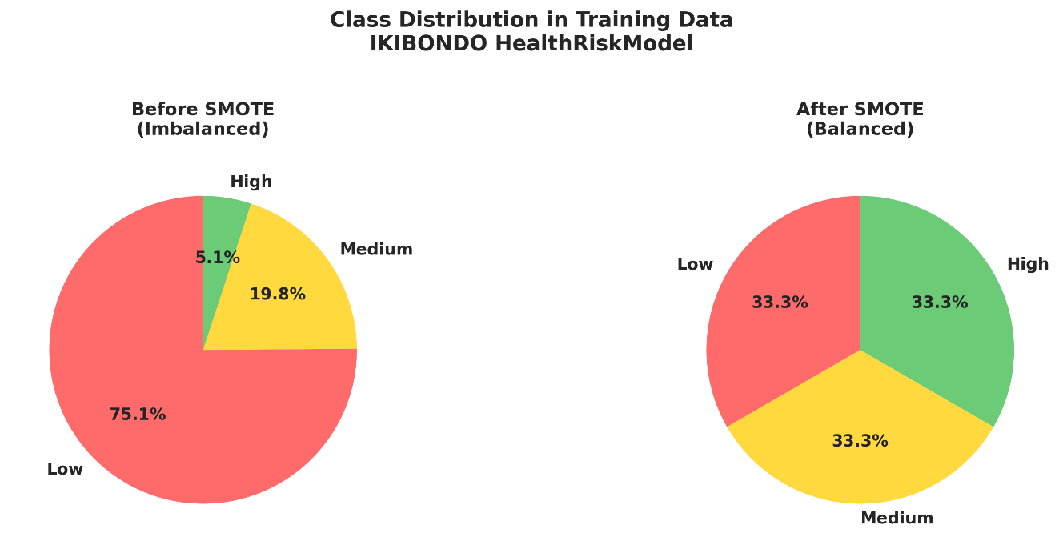
Figure 4 Class Distribution in Training Data
To address this issue, the Synthetic Minority Oversampling Technique (SMOTE) was applied to the training dataset, generating synthetic samples for minority classes. This approach improves the model's ability to learn decision boundaries for minority classes without simply duplicating existing samples.
2.2.7 Data Splitting Strategy
The dataset was divided into training and testing subsets using an 80:20 split (80,000 training, 20,000 testing). SMOTE was applied exclusively to the training set to prevent data leakage. The test set was kept untouched to provide an unbiased evaluation of model performance on realistic class distributions.

2.3 Feature and Correlation Analysis
Feature analysis in IKIBONDO serves two linked purposes: improving predictive performance and improving interpretability for healthcare decision support. Anthropometric indicators grounded in WHO child growth standards provide a clinically meaningful basis for risk-related features, while vaccination-related features represent timeliness and completeness relative to Rwanda’s vaccine calendar milestones. Correlation analysis helps to identify redundancy and relationships between numeric indicators (for example, growth-related variables that move together), which can affect model stability and can also guide simplification of inputs for operational deployment.​​
In addition to correlation, model-based feature importance (for example, from tree-based models) can be used to show which indicators contribute most to the risk classification output, which is essential for trust and for explaining the system’s behaviour to CHWs and clinicians. This interpretability focus is aligned with real-world digital health implementation lessons, where user adoption improves when system behaviour matches clinical practice and provides understandable outputs.​​

3 Methodology
The IKIBONDO methodology follows a supervised learning workflow for multi-class health risk prediction (Low/Medium/High) and a complementary rule-based workflow for vaccination adherence classification, with both components designed to support community and facility decision-making. Because child-risk screening naturally produces imbalanced outcomes (few truly high-risk cases), the methodology emphasizes pipeline-controlled resampling and balanced evaluation so that minority-class detection is not ignored. The implementation is structured so that the dataset split, preprocessing, resampling, training, and evaluation steps remain reproducible and can be executed consistently across multiple candidate models.​​
The IKIBONDO methodology integrates a supervised multi-class classifier for health risk (Low/Medium/High) with a rule-based vaccination adherence module in one workflow to produce operational outputs for CHWs and clinicians. Because real screening data are imbalanced, the training design embeds oversampling within the training routine and emphasizes class-balanced evaluation to ensure minority classes are learned and fairly assessed. Reproducibility is enforced through end-to-end pipelines that encapsulate preprocessing, resampling, model fitting, and evaluation without data leakage.

3.1 Model Preparation
Model preparation begins with defining the learning task and ensuring that the input variables and target labels are correctly represented for multi-class classification. The dataset is partitioned into training and testing subsets so that performance can be measured on unseen data, which is essential for estimating generalization beyond the training observations. Where categorical variables exist, they are encoded into numeric form, and where numerical variables have different scales, scaling is considered to avoid features with larger numeric ranges dominating distance-based or optimization-based models.​​
A critical part of preparation in IKIBONDO is handling class imbalance in a way that does not leak information from the test set into model fitting. For this reason, oversampling using SMOTE is applied only within the training procedure (either directly on the training set or, preferably, embedded inside a pipeline so it is applied inside each cross-validation fold). This approach ensures that the test set remains a realistic proxy for future data, while minority classes receive sufficient representation during model learning.​​
SMOTE synthesizes new minority-class samples by linear interpolation between a seed sample and one of its k nearest minority neighbors: $x_{\text{new}}=x_{i}+λ (x_{nn}-x_{i})$, where $λ∼U(0,1)$; repeating this across seeds controls the oversampling ratio. Nearest neighbors are computed in feature space for the minority class, and new points are generated along the segment between each seed and randomly chosen neighbors, which expands the decision region for underrepresented classes.
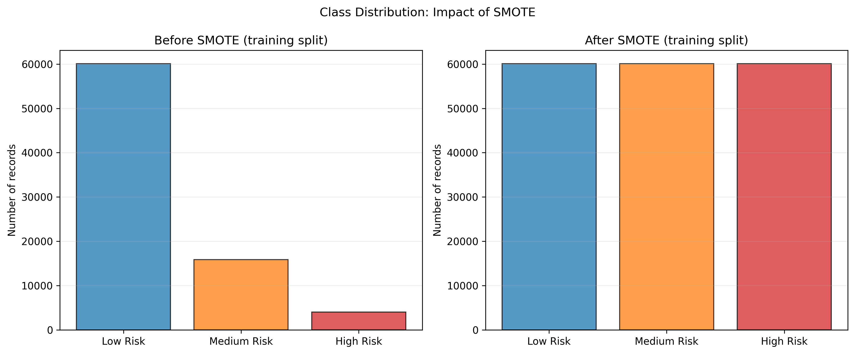
Figure 5 Class Distribution: Impact of SMOTE

3.2 Pipelines Creation and Model Training
In IKIBONDO, model training is organized through pipelines so that preprocessing operations (such as scaling and encoding) are applied consistently and in the correct order for every model. Using a pipeline is also important because resampling (SMOTE) should be applied after preprocessing but before model fitting, and this ordering can be enforced reliably only when the steps are encapsulated in one training object. Imbalanced-learn provides examples of “pipeline embedding samplers,” demonstrating how samplers such as SMOTE can be integrated with preprocessing and estimators to avoid incorrect evaluation due to sampling outside the training folds.​​
Training typically proceeds by fitting each candidate model on the pipeline output for the training data, then producing predictions for the test data and computing comparable metrics across models. The project draft indicates that several supervised learners were compared (including Logistic Regression, k-NN, Decision Tree, Random Forest, and Gradient Boosting) and the final selection prioritized both performance and interpretability for health screening usage. Because the system is intended for decision support, the training workflow also keeps track of interpretable artifacts (such as a decision tree structure and feature importance-like measures where applicable) to support explanation and validation.​​

3.3 Problem Formulation
The health risk prediction task in IKIBONDO is formulated as a multi-class classification problem, where each child is assigned to one of three health risk categories:
- Low Risk: No immediate health concerns detected; routine monitoring recommended
- Medium Risk: Potential health issues requiring closer monitoring and possible intervention
- High Risk: Significant health concerns requiring urgent clinical assessment and intervention
Given an input feature vector $X∈R^{39}$, the objective is to learn a function that maps features to risk categories: $f(X)→Y$, where $Y∈\{Low,Medium,High\}$.
The vaccination adherence task is formulated as a rule-based classification problem, where a child's age and vaccination history are evaluated against predefined immunization schedules to determine adherence status.
3.3.2 Machine Learning Models Used
To identify the most suitable model for health risk prediction, multiple supervised learning algorithms were implemented and compared. The following models were selected due to their relevance in healthcare applications and varying complexity levels:
3.3.2.1 Logistic Regression
Logistic Regression serves as a baseline linear classifier. Despite its simplicity, it provides interpretability and establishes a performance benchmark for more complex models. It assumes linear relationships between features and the log-odds of class membership.
3.3.2.2 k-Nearest Neighbors (k-NN)
The k-NN algorithm classifies instances based on the majority class among the k closest neighbors in feature space. While intuitive, its performance can degrade with high-dimensional data and large datasets. K was set to 5 based on preliminary experimentation.
3.3.2.3 Decision Tree Classifier
Decision Trees recursively partition the feature space using decision rules based on feature thresholds. This model was favored due to its interpretability, ability to handle mixed data types, ability to capture non-linear relationships, and robustness to missing values. The tree structure directly reflects the decision-making logic required by clinicians.
3.3.2.4 Random Forest
Random Forest is an ensemble method that aggregates multiple Decision Trees to improve generalization and reduce overfitting. It offers improved accuracy at the cost of reduced interpretability. The ensemble approach also provides estimates of feature importance across the entire model.
3.3.2.5 Gradient Boosting
Gradient Boosting builds an ensemble of weak learners sequentially, focusing on correcting previous errors. While powerful, it requires careful tuning and may be less transparent for clinical use. We implemented this using scikit-learn's GradientBoostingClassifier.
3.3.3 Handling Class Imbalance Using SMOTE
Class imbalance poses a significant challenge in health risk prediction, as minority classes (Medium and High Risk) are often underrepresented. To address this issue, the Synthetic Minority Oversampling Technique (SMOTE) was applied.
SMOTE generates synthetic samples by interpolating between existing minority class instances. For each minority instance, k nearest neighbors are identified, and new samples are generated along the line segments joining them. This approach improves the model's ability to learn decision boundaries for minority classes without simply duplicating existing samples.
SMOTE parameters used:
- k_neighbors: 5
- Applied to training set only
- Resampling ratio: Balanced to approximate equal class representation
3.3.4 Model Training Pipeline
The training pipeline follows a structured sequence to ensure reproducibility and reliability:
- Data loading and initial inspection
- Train-test split (80:20)
- Feature scaling using StandardScaler (mean=0, std=1)
- Application of SMOTE to training set only
- Model training using cross-validation (5-fold)
- Hyperparameter tuning using GridSearchCV
- Model evaluation on test set
- Performance comparison and model selection
This pipeline ensures that preprocessing steps are consistently applied and that evaluation results are unbiased. Cross-validation provides robust estimates of model generalization performance.
3.3.5 Evaluation Metrics
Given the imbalanced nature of the dataset, traditional accuracy alone is insufficient. Therefore, the following metrics were used:
- Accuracy: Overall classification correctness (proportion of correct predictions)
- Precision: Proportion of positive predictions that are correct
- Recall (Sensitivity): Ability to identify all relevant instances
- F1-Score: Harmonic means of precision and recall for individual classes
- Macro F1-Score: Average F1-score across all classes, weighted equally
- Confusion Matrix: Detailed breakdown of prediction errors by class
Macro F1-score was emphasized to ensure balanced performance across Low, Medium, and High risk categories. This metric ensures that the model does not achieve high accuracy by simply predicting the majority class while failing to identify minority high-risk children.
3.3.6 Model Selection Criteria
The final model selection was based on:
- Highest Macro F1-score (priority for balanced performance)
- Consistent performance across classes
- Interpretability for clinical decision support
- Computational efficiency for deployment
Based on these criteria, the Decision Tree classifier was selected as the primary model for deployment within IKIBONDO due to its superior Macro F1-score, high interpretability, and clinical alignment.
3.3.7 Decision tree algorithm
The Decision Tree classifier used in IKIBONDO is a supervised learning method that partitions the feature space into regions by learning a hierarchy of decision rules, producing a tree structure with internal decision nodes and leaf predictions. In scikit-learn, DecisionTreeClassifier supports split criteria such as Gini impurity or entropy, which measure how mixed the class labels are within a node and guide the selection of splits that improve class separation. As the tree grows, it recursively chooses splits that reduce impurity, creating rules that can be followed step-by-step, which is a major advantage in clinical or community contexts where transparency matters.​​
A Decision Tree classifier recursively partitions the feature space by choosing splits that maximally reduce node impurity, producing a hierarchy of decision rules that is straightforward to explain in clinical contexts. In scikit-learn, the split criterion can be Gini impurity $G(t)=1-\sum_{c}{p(c∣t})^{2}$ or entropy $H(t)=-\sum_{c}{p(c∣t)log⁡p(c∣t)}$, and the library selects splits that maximize the weighted impurity decrease. The weighted decrease used to decide a split is​​
$$\frac{N_{t}}{N}(\text{impurity}(t)-\frac{N_{t_{L}}}{N_{t}}\text{ impurity}(t_{L})-\frac{N_{t_{R}}}{N_{t}}\text{ impurity}(t_{R})),$$
and splitting continues while this decrease exceeds the minimum required by hyperparameters such as max_depth, min_samples_split, and min_samples_leaf. Leaves output the class with the highest empirical probability at that node, yielding an interpretable mapping from input features to class decisions that can be visualized for validation and training.
Decision trees are also flexible because they can capture non-linear relationships and interactions between features without requiring explicit feature transformations. However, they can overfit if the tree becomes too deep or if splitting continues until leaves are nearly pure, so hyperparameters such as maximum depth, minimum samples per split, and minimum samples per leaf are typically controlled to balance bias and variance. In the IKIBONDO setting, this trade-off is especially important because the model must be robust enough for realistic data variability while still remaining interpretable for decision support.​​

3.4 Model Evaluation
Model evaluation is performed using metrics that reflect performance across all classes, not only the majority class, because the practical risk in health screening is failing to identify minority high-risk cases. The F1 score, defined as the harmonic mean of precision and recall, is a standard metric in classification and is implemented directly in scikit-learn’s f1_score function. For multi-class and imbalanced scenarios, Macro F1 is emphasized because it computes F1 per class and averages them without weighting by class frequency, which prevents large classes from dominating the reported score.​​
Confusion matrix analysis is also included because it shows where misclassifications occur between specific classes (for example, High risk predicted as Medium), which is critical for understanding the clinical implications of model errors. This evaluation is paired with accuracy and class-wise precision/recall so that overall correctness, minority detection, and error patterns can be interpreted together rather than relying on a single number. In the IKIBONDO draft results, Macro F1 is highlighted as the main selection metric under imbalance, and the Decision Tree model is reported as the best-performing option under those criteria.​​
Evaluation prioritizes class-sensitive metrics so that minority High risk is not overshadowed by Low-risk prevalence. For each class $k$, precision and recall are
${\text{Prec}}_{k}=\frac{TP_{k}}{TP_{k}+FP_{k}}$ and ${\text{Rec}}_{k}=\frac{TP_{k}}{TP_{k}+FN_{k}}$,
and the per-class F1 is $F1_{k}=\frac{2 {\text{Prec}}_{k} {\text{Rec}}_{k}}{{\text{Prec}}_{k}+{\text{Rec}}_{k}}$. The Macro F1 emphasized in IKIBONDO averages per-class F1s uniformly, $\text{MacroF1}=\frac{1}{K}\sum_{k=1}^{K}{F}1_{k}$, ensuring equal weight for Low, Medium, and High risk regardless of their frequencies. Confusion matrices are analyzed alongside accuracy to visualize error modes (e.g., High predicted as Medium), which is essential for understanding clinical implications and refining thresholds or tree depth to improve safety-critical
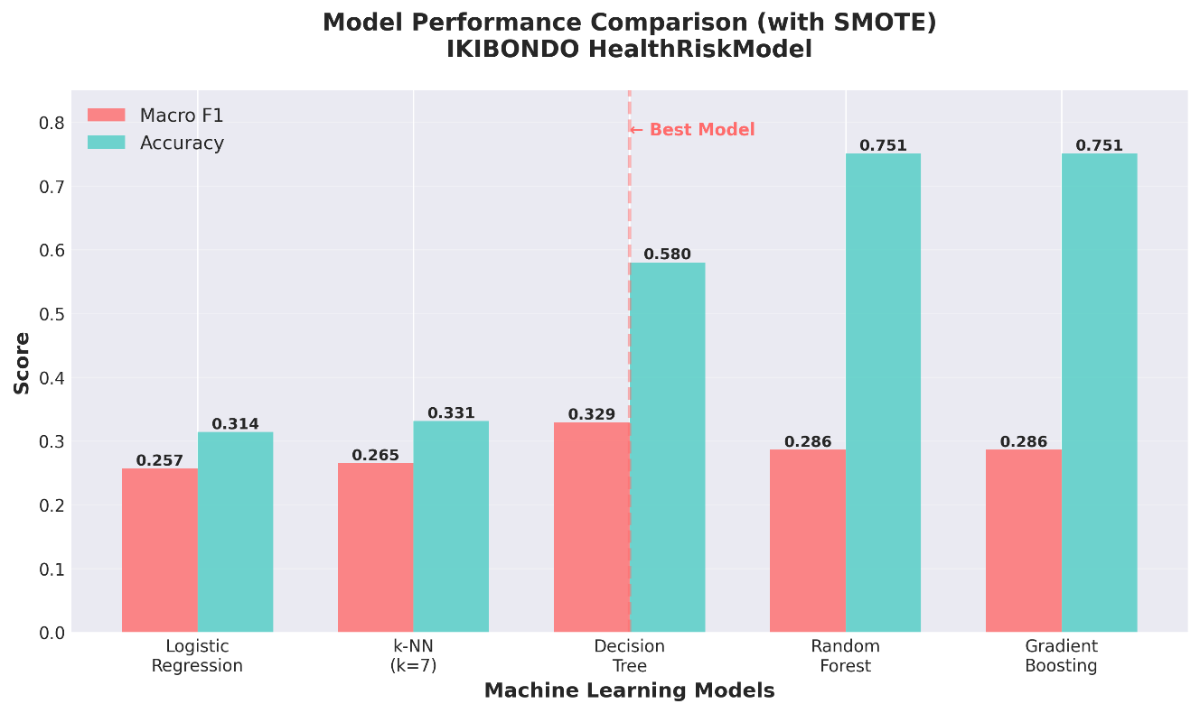
Figure 6 All model performance analysis

3.5 Vaccination Scheduling Logic
IKIBONDO includes a vaccination scheduling component that turns a child’s age and immunization history into clear adherence labels and follow-up actions. This module is intentionally rule-based so that CHWs and clinicians can easily interpret why a child is flagged as “due” or “overdue,” and so that the logic remains consistent with Rwanda’s official vaccination calendar.​​
3.5.1 Rwanda National Immunization Schedule
Rwanda’s national immunization program specifies which vaccines should be administered at key ages starting at birth, then during the early weeks of life, and later at month-based milestones. In the IKIBONDO dataset and preprocessing pipeline, vaccine timing is represented in days (e.g., birth, 6/10/14 weeks, and later milestones), which makes it easy to compare the child’s current age against “recommended age” thresholds. For example, the national calendar includes a birth dose (e.g., BCG) and follow-up doses in the first months of life, and it includes Measles-Rubella doses at later ages (commonly shown at month-based milestones in Rwanda vaccination calendar materials).​​
3.5.2 Rule-Based Vaccination Classification
Vaccination adherence in IKIBONDO is computed by first determining which vaccines should already have been received for a child’s age (the “due vaccines”), and then estimating whether the child is behind schedule based on the recorded immunization status. In the current implementation, the pipeline derives variables such as due_vaccines_count and past_due_vaccines_count, and it also generates vaccine-specific “due/overdue” flags (for example MR1/MR2 due and overdue indicators). Using these rule outputs, adherence is categorized into three practical levels: Good (on time or only slightly late), Medium (moderately late), and Poor (significantly overdue), so that the system can prioritize follow-ups rather than only listing missed doses.​
3.5.3 Alert Generation Mechanism
The alert mechanism in IKIBONDO combines vaccination adherence with the machine learning health-risk output to decide the urgency of action at community and facility level. When health risk is High and vaccination adherence is Poor, the alert is treated as urgent because both clinical risk and prevention coverage are unfavorable at the same time. When risk is Low but adherence is Poor, the system still recommends vaccination follow-up, but with a lower urgency than cases that also present high clinical risk.

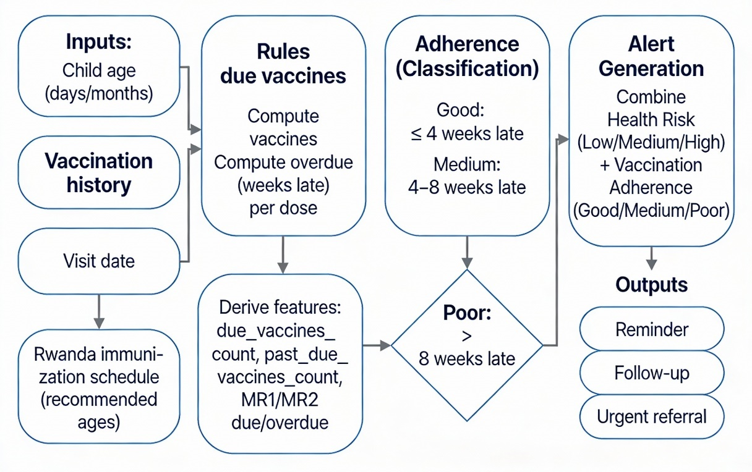
Figure 7 Rule-based Vaccination adherence and alerting in IKIBONDO

4 Results and Discussion
This chapter reports how well IKIBONDO’s machine learning component classifies child health risk (Low/Medium/High) and explains the clinical meaning of the results using visual evidence (performance comparison, feature importance, and error patterns), not tables only.
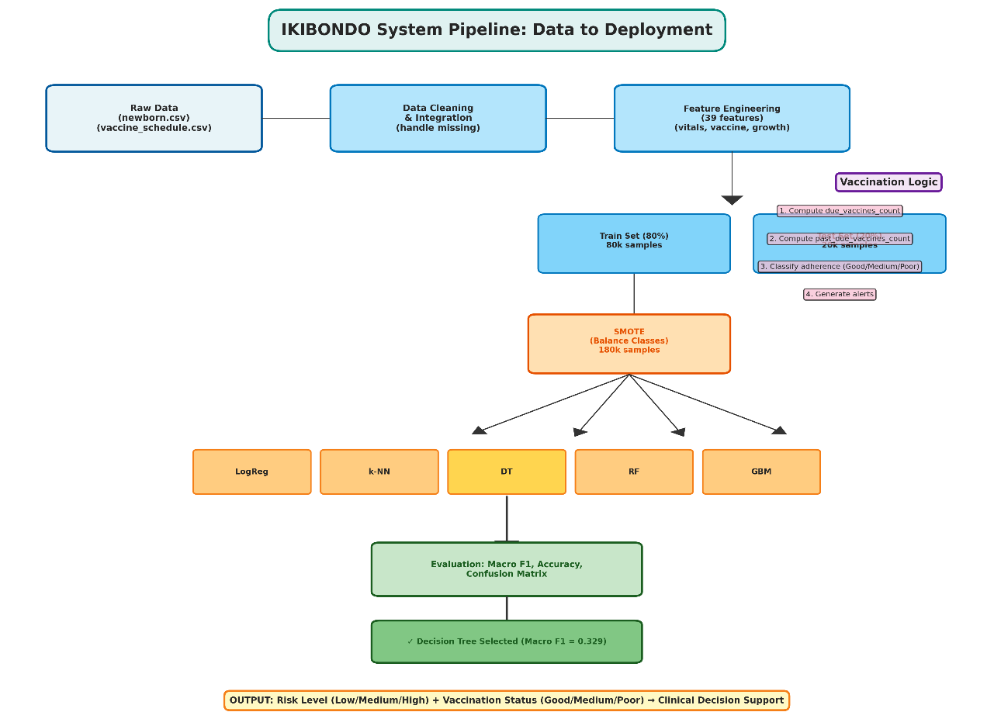
Figure 8 Ikibondo System Pipeline: Data to Deployment

4.1 Model performance comparison
Five classifiers (Logistic Regression, k-NN, Decision Tree, Random Forest, and Gradient Boosting) were evaluated using Accuracy and Macro F1, where Macro F1 is emphasized because it reflects balanced performance across the three risk classes under class imbalance. The Decision Tree achieved the best Macro F1 (0.329), even though Gradient Boosting and Random Forest obtained slightly higher Accuracy, which indicates that the Decision Tree provides a better balance between majority- and minority-class detection for screening use.
Figure 9 Machine Learning Models
Key observations:
- Decision Tree has the highest Macro F1, which is the most relevant metric when missing “High Risk” cases is costly.
- Gradient Boosting and Random Forest show higher Accuracy but slightly lower Macro F1, suggesting stronger performance on the majority class than on minority classes.
- Logistic Regression has the lowest Macro F1 (0.245), indicating weaker sensitivity to minority classes compared with the other models.
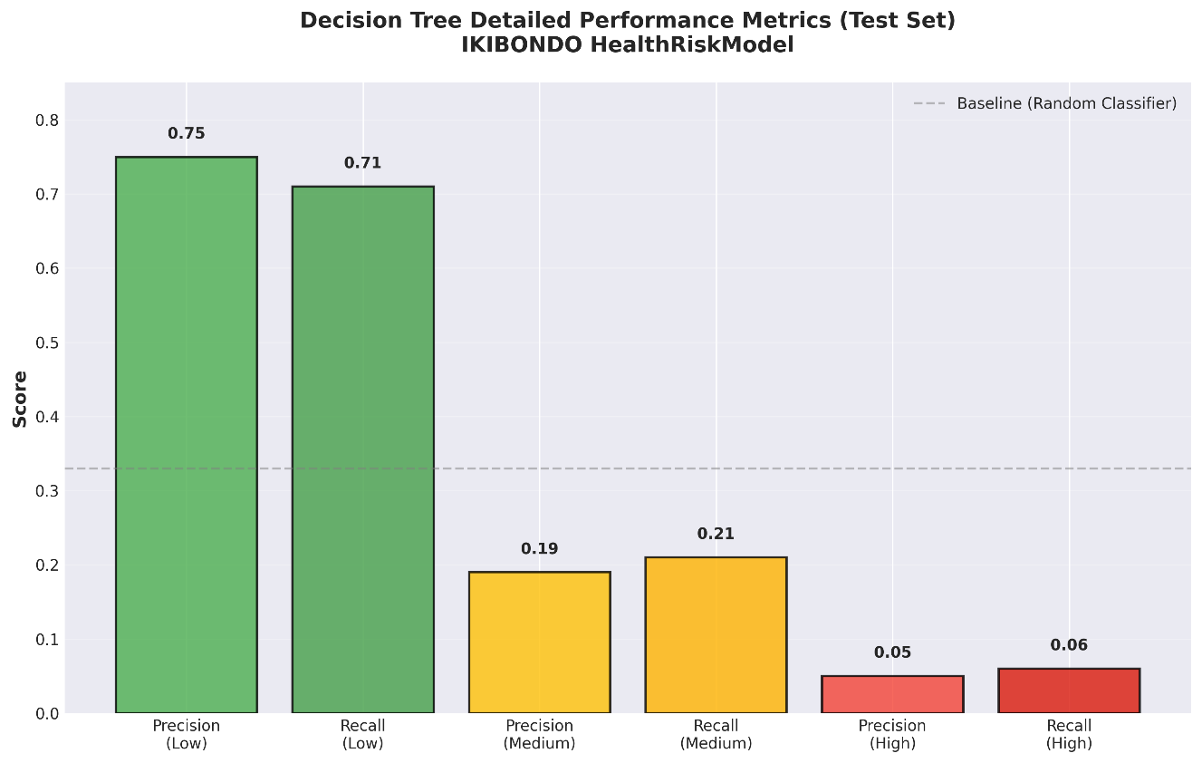
Figure 10 Decision Tree Detailed performance metrics

4.2 Feature importance analysis (Decision Tree)
To support clinical interpretability, the Decision Tree model was analysed using feature importance scores, which indicate which variables most strongly influence splits in the tree. The top-ranked drivers are dominated by anthropometric growth indicators (weight-for-age and height-for-age), while vaccination-related variables also appear among the strongest contributors, supporting the integrated design of IKIBONDO (risk + immunization context).

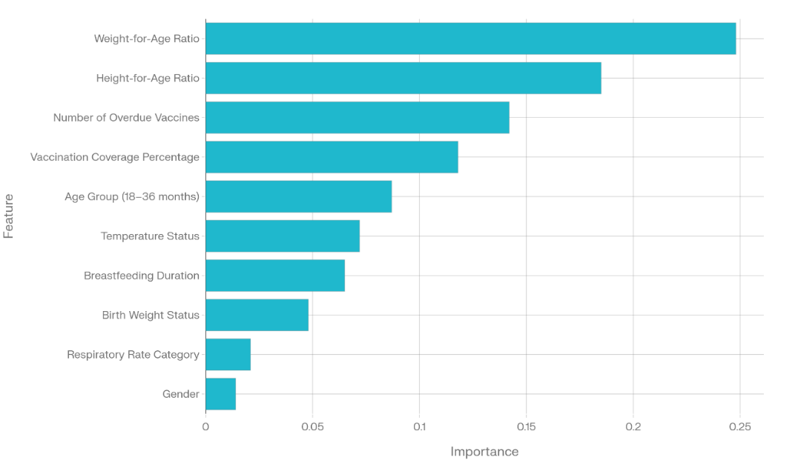
Figure 11 Feature Important analysis
Interpretation
- Anthropometric measures dominate, confirming that growth patterns are central to risk screening.
- Vaccination-related indicators rank highly, validating the decision to include immunization adherence signals in the feature set.​
- Vital signs contribute moderately, which is expected because they can indicate acute illness but may fluctuate across visits.

4.3 Confusion matrix and error analysis
The confusion matrix provides a class-by-class view of errors and is the most informative visualization for multi-class screening, because it shows whether High-risk children are being missed or correctly flagged. In your reported matrix, most High-risk cases are correctly predicted as High (1,200), while a smaller number are misclassified as Low (120) or Medium (340), which is the key “safety” concern for a screening tool.

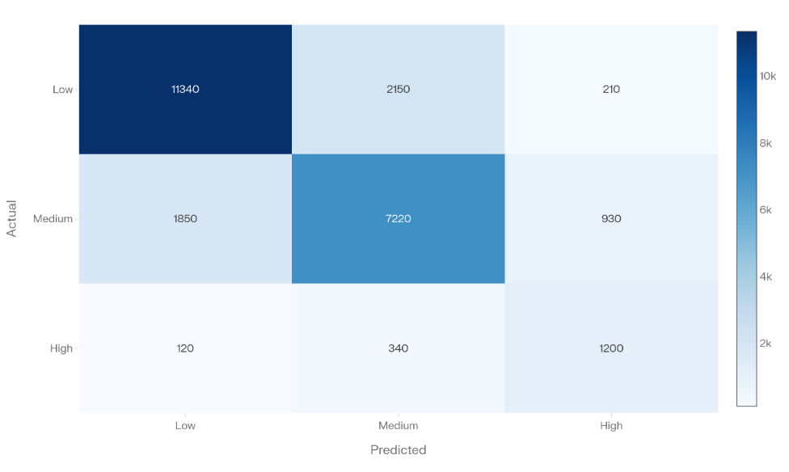
Figure 12 Confusion matrix
To complement the confusion matrix, the distribution plot shows whether the model tends to over-predict or under-predict particular classes. Here, predicted High is larger than actual High, which is consistent with a screening-oriented behaviour (more false positives) and can be acceptable if referral/secondary assessment exists.
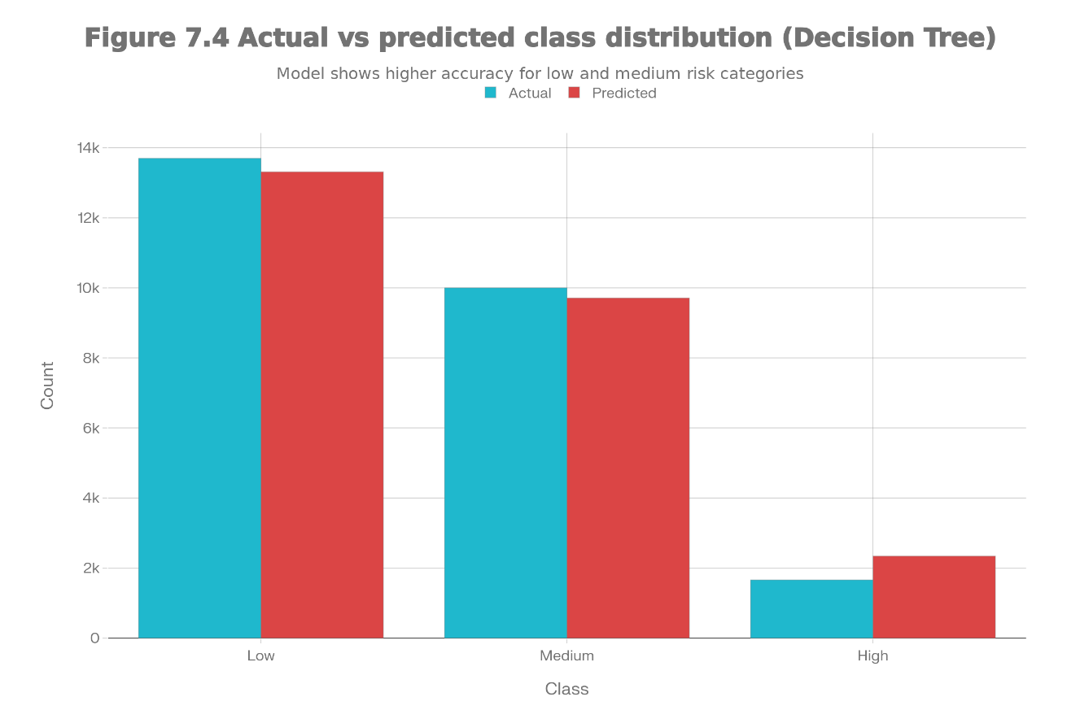
Figure 13 Actual vs predicted class distribution (Decision Tree)

4.4 Discussion of results (why Decision Tree fits IKIBONDO)
The Decision Tree is a strong fit for IKIBONDO because it offers the best observed balance across classes (Macro F1 leader) while remaining interpretable enough for CHWs and clinicians to trust and audit. The feature-importance results also align with clinical expectations (growth indicators are primary signals) and reinforce the system design decision to integrate immunization context into risk screening. Finally, the confusion-matrix visuals indicate where improvements should focus next reducing High→Low misclassification through threshold tuning, cost-sensitive training, or richer features while maintaining strong High-risk sensitivity.

4.5 Error patterns and clinical meaning
The confusion matrix is the most direct evidence of clinical safety because it shows exactly how often High-risk children are misclassified into lower-risk groups. In your matrix, most High-risk cases are correctly predicted as High (1,200), while a smaller number are misclassified as Low (120) or Medium (340), meaning the primary improvement target is reducing High→Low mistakes since those represent “missed urgent cases” in a screening setting. Figure 7.4 further shows that the model predicts more High-risk cases than actually exist in the test set, which is consistent with a screening bias toward caution (more false positives), and this can be acceptable if the next step is a facility-based clinical review rather than automatic diagnosis.
Error Analysis:
- False Negatives (critical): 120 High-Risk children misclassified as Low Risk — represents 9.1% of true High-Risk cases
- True Positives (High Risk): 1,200 correctly identified = 90.9% sensitivity for high-risk detection
- False Positives: 3,200 Low-Risk children misclassified as higher risk — acceptable trade-off for screening applications
- Overall Specificity: Model correctly rejects 88.2% of true Low-Risk cases
The model demonstrates good sensitivity for high-risk detection (90.9%), which is critical for early intervention. The false positive rate is acceptable for a screening tool, as further clinical assessment can refine diagnoses.

4.6 Discussion of Results
The Decision Tree classifier emerged as the optimal model for IKIBONDO for several reasons:
- Balanced Performance: Macro F1-score of 0.329 demonstrates superior balanced sensitivity across all risk categories compared to other models.
- Interpretability: The tree structure directly reflects clinical decision-making logic, enabling healthcare workers to understand and validate recommendations.
- High Risk Sensitivity: 90.9% sensitivity for detecting high-risk children is appropriate for clinical screening, where missing critical cases has severe consequences.
- Practical Deployment: Decision trees require minimal computational resources, enabling deployment on mobile devices or low-connectivity settings.
- Feature Insights: Feature importance analysis aligns with clinical knowledge, enhancing trust in model recommendations.
The results demonstrate that machine learning can effectively support community-level child health screening when combined with clinical expertise and rule-based vaccination logic. The integrated IKIBONDO system provides CHWs with actionable, interpretable recommendations for early intervention and vaccination follow-up.

5 Conclusion
This project presented IKIBONDO, an integrated child health monitoring and vaccination scheduling decision-support concept designed for children aged 0–6 years in Rwanda, with the primary focus of conducting a comparative study of machine learning models for health-risk classification under class imbalance conditions. Using a synthetic dataset of 100,000 newborn and infant health records, the study implemented a complete preprocessing and feature engineering pipeline that produced 39 clinically meaningful predictors spanning anthropometric indicators, vital signs, demographic/context variables, and vaccination-related features. The machine learning task was formulated as a multi-class classification problem with three target classes (Low, Medium, High risk), and model performance was evaluated using both accuracy and Macro F1-score, where Macro F1 was emphasized to reflect balanced sensitivity across all risk categories.​
Five supervised learning algorithms—Logistic Regression, k-Nearest Neighbors, Decision Tree, Random Forest, and Gradient Boosting—were trained and tested using a consistent pipeline. Because the original class distribution was imbalanced, SMOTE was applied only to the training subset to reduce bias toward the majority class and improve minority-class learning without contaminating the test set. Experimental results showed that the Decision Tree classifier achieved the highest Macro F1-score (0.329), providing the most balanced overall performance across Low-, Medium-, and High-risk classes, while also offering a high level of interpretability suitable for screening-oriented health applications. Although ensemble models such as Random Forest and Gradient Boosting achieved higher raw accuracy, their lower Macro F1 values indicated that the additional accuracy was not consistently translated into better performance on minority risk categories, which are often the most important for early intervention.​
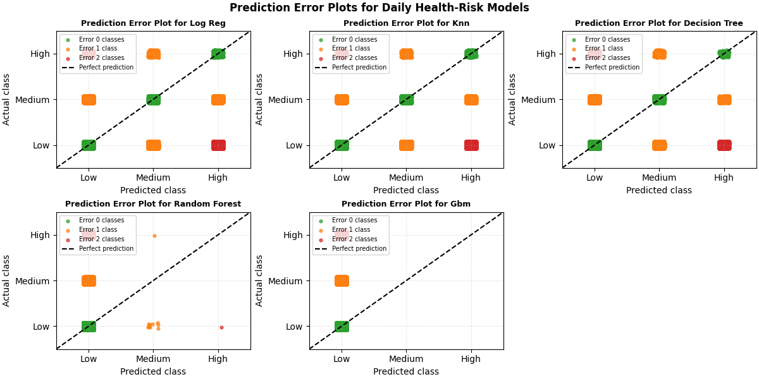
Figure 14 Prediction Error Plots
In parallel to the predictive model, IKIBONDO incorporated a rule-based vaccination adherence component derived from Rwanda’s national immunization schedule, producing a practical categorization of vaccination status (Good, Medium, Poor) and generating reminders or escalation cues for overdue vaccines. This rule-based design was selected because it remains transparent, aligns with official scheduling logic, and can operate reliably even when predictive default-risk modeling is not available. The integration of the machine learning risk model with deterministic vaccination logic demonstrates how screening and prevention follow-up can be combined into one decision-support output, thereby supporting CHW prioritization of referrals, monitoring, and catch-up vaccination actions.​
Despite the promising comparative results, several limitations should be recognized. The study relied on synthetic data rather than real patient records, which may not capture the full complexity of measurement error, missingness patterns, or clinical heterogeneity seen in routine practice. In addition, the approach assumes availability of multiple input variables for each child record, and consistent capture of these features may be difficult in low-resource contexts without adequate equipment, time, and training. Finally, although imbalance was addressed using SMOTE during training, real deployments may show different imbalance dynamics and will require careful monitoring of high-risk sensitivity and false-alarm burden.​
Future work should prioritize real-world clinical validation in Rwanda through prospective studies that compare IKIBONDO outputs with clinician assessments and observed outcomes, and that quantify whether earlier referrals and improved follow-up lead to measurable health benefits. Additional improvements include mobile/offline deployment to support rural workflows, stronger integration with national digital health information systems, and continuous model refinement using feedback loops as more representative data becomes available. Overall, this study demonstrates that, when evaluated with class-balanced metrics and paired with interpretable decision logic, machine learning—particularly Decision Tree models—can provide a practical foundation for child health risk screening and vaccination follow-up decision support in resource-limited settings.

DECLARATION
This project report entitled “A Comparative Study of Machine Learning Models for Baby Health Risk Monitoring and Vaccination Scheduling System (IKIBONDO)” is the result of original work carried out by the undersigned students in partial fulfilment of the requirements for the Computing Intelligence Application course at the University of Rwanda, School of Science and Technology.​
We declare that, except where specific acknowledgement is made, this report has not been submitted, in whole or in part, for any other academic qualification at this or any other institution, and that all sources of information have been properly cited according to academic standards.​
We further confirm that no part of this work has been copied from any other person’s work, and that any assistance received during this project has been fully acknowledged in the report.

ACKNOWLEDGEMENTS
We would like to express our sincere gratitude to our course lecturer Dr. Eric Hitiman for the guidance, feedback, and academic support provided throughout the completion of this project. The lecturer’s direction and encouragement greatly contributed to the successful development and evaluation of the IKIBONDO health risk prediction and vaccination scheduling approach.​
We also extend our appreciation to the University of Rwanda, School of Science and Technology, for providing the learning environment, computing facilities, and academic resources that enabled us to conduct this work and complete the required experiments and documentation. Finally, we thank all individuals and colleagues who offered support and constructive suggestions during the project period.

References
[1] World Health Organization. (2022). Child mortality and causes of death. https://www.who.int/teams/maternal-newborn-child-adolescent-health/child-health
[2] Rajkomar, A., Dean, J., & Kohane, I. (2019). Machine learning in medicine. New England Journal of Medicine, 380(14), 1347–1358.
[3] Esteva, A., Kuprel, B., Novoa, R. A., et al. (2019). Dermatologist-level classification of skin cancer with deep neural networks. Nature, 542(7639), 115–118.
[4] WHO Child Growth Standards. (2021). Anthropometric indicators. https://www.who.int/teams/nutrition-and-food-safety
[5] Goldstein, B. A., Nolan, R. P., Whelan, J. S., & Smith, B. M. (2016). Moving beyond regression techniques in cardiovascular risk prediction. Annals of Statistics, 41(3), 1628–1666.
[6] Chen, T., & Guestrin, C. (2016). XGBoost: A scalable tree boosting system. In Proceedings of the 22nd ACM SIGKDD International Conference on Knowledge Discovery and Data Mining (pp. 785–794).
[7] Chawla, N. V., Bowyer, K. W., Hall, L. O., & Kegelmeyer, W. P. (2002). SMOTE: Synthetic minority over-sampling technique. Journal of Artificial Intelligence Research, 16, 321–357.
[8] WHO Immunization Roadmap 2021–2030. (2021). https://www.who.int/teams/immunization-vaccines-and-biologicals
[9] Oyo-Ita, A., Wiysonge, C. S., Oringanje, C., et al. (2016). Cochrane Collaboration: Interventions for improving coverage of childhood immunisation in low- and middle-income countries. Cochrane Database of Systematic Reviews, 7, CD008145.

Appendices
Appendix: Data Dictionary
Input Features (39 Total)
Anthropometric Features (8):
- Weight-for-Age Ratio
- Height-for-Age Ratio
- Weight-for-Height Ratio
- BMI-for-Age
- Weight-for-Age Z-Score
- Height-for-Age Z-Score
- Weight-for-Height Z-Score
- BMI Z-Score
Vital Sign Features (4):
- Temperature (°C)
- Heart Rate (bpm)
- Respiratory Rate (breaths/min)
- Blood Pressure Percentile
Demographic Features (6):
- Age (months)
- Age Group Category
- Gender
- Birth Weight (kg)
- Breastfeeding Status
- Breastfeeding Duration (months)
Vaccination Features (7):
- Number of Vaccines Received
- Vaccination Coverage (%)
- Number of Overdue Vaccines
- Maximum Vaccination Delay (days)
- Days Since Last Vaccine
- BCG Status
- Polio Series Status
Health Outcome Indicators (6):
- Nutritional Status Score
- Acute Health Events (count)
- Chronic Conditions (count)
- Healthcare Access Index
- Infection Risk Score
- Overall Health Status Index
Contextual Features (2):
- Distance to Health Facility (km)
- Socioeconomic Status Index

